Technical Design

SAP on Azure
Platform Services

Synlait Limited
24/06/2020 – Version 0.3

Document Control

Copyright
The material contained in this Document has been prepared by Zag Limited (Zag) (company number 807283, formerly Soltius New Zealand Limited) and is confidential and proprietary to Synlait Milk Limited (Synlait). The material will be held in strict confidence by the recipient and will not be used, in whole or in part, for any purpose other than the purpose for which it is provided without the prior written consent of Synlait. In no event shall Synlait or Zag be liable to anyone for direct, special, incidental, collateral or consequential damages arising out of the use of this material.

Document format Copyright 2013 - 2020 Zag Limited - all rights reserved.
Design Template 01.07.2019

Document Versioning
Current Version | 0.3
Release Date | 23.06.2020
Released By

Version | Author | Date | Description | Distribution
0.1 | Document Contributors | 17.03.2020 | Initial draft | Zag Limited
0.2 | Document Contributors | 25.03.2020 | Updates after design review | Zag Limited
0.3 | Document Contributors | 23.06.2020 | Added DR and Standby DB Updates | Zag Limited

Document Contributors
The following personnel contributed to the delivery of this Document.
Name | Organisation | Role | Contact Details
Khushal Singh | Zag Limited | Co-Author | khushal@zag.team
Deepender Baloonie | Zag Limited | Co-Author | deepender@zag.team
Craig Davis | Zag Limited | Reviewer | craigd@zag.team

Reference Material
The following list of reference material was used in the preparation of this Document or is relevant to its understanding.
Reference | Author / Source
Cloud Adoption Framework for Azure | https://docs.microsoft.com/en-us/azure/cloud-adoption-framework/reference/
SAP on Azure | https://azure.microsoft.com/en-us/solutions/sap/azure-solutions/
SAP HANA database backup in Azure VMs | https://docs.microsoft.com/en-us/azure/backup/sap-hana-db-about

Table of Contents
Table of Contents 3
1 Overview 5
1.1 Purpose of this Document 5
1.2 Target Infrastructure Architecture (High Level) 5
2 Foundation 5
2.1 Customer Code 5
2.2 Azure Accounts 6
2.3 Azure Subscription 6
2.4 Regions and Availability Zones 6
2.5 Resource Naming Convention 7
3 Network 9
3.1 Overview 9
3.2 Virtual Network (VNet) 9
3.3 VNet Peering 10
3.4 Connectivity 10
3.5 Subnets 10
3.6 Public Internet Egress 13
3.7 Public Internet Ingress 13
3.8 Routing 13
3.9 Domain Name Server (DNS) 14
3.10 Azure proximity placement groups 15
4 Applications 15
4.1 Product Landscape 16
4.2 Application Add-ons 16
4.3 Supporting Platform Infrastructure 17
4.4 Tiered Landscape 17
4.5 Software Development Life Cycle 18
4.6 SAP S/4HANA Sandbox 18
5 Platform 18
5.1 Operating Systems 18
5.2 Compute Instances 19
5.3 Databases 20
5.4 Application Matrix 21
5.5 Patch Management 22
5.6 Time and Locale Settings 22
5.7 Storage 22
5.8 Linux User Accounts 23
5.9 Connectivity 23
6 SAP 24
6.1 Environment 24
6.2 Correction and Transport System 30
6.3 SAP Client Strategy 30
6.4 System Landscape Directory 31
6.5 Software Vendor Support 31
7 S/4HANA Target State 32
7.1 SAP Sizing 32
7.2 Infrastructure Requirements 32
7.3 Hour of Operations 33
8 Operations 33
8.1 Solution Manager 33
9 High Availability/Disaster Recovery 33
10.1 Backup & Recovery 34
10.2 Testing 36
10 Monitoring & Logging 36
11.1 Infrastructure monitoring 36
11.2 Cloud Governance 37
11.3 Platform Logging 37
11.3.1 Azure Platform Logs 37
11.3.2 System Logs 37
11.3.3 Network Flow Logs 37
11.3.4 Application Logs 37
11.3.5 HTTPS Logging 37
11 Security 38
12.1 Securing Azure Platform 38
12.2 SAP Access Requirements 38
12.3 Single Sign-On 39
12.4 Password Repository 39
12.5 SAP Standard Users 39
12.6 Digital Certificates (System) 39
12.7 Secure Network Communications 39
12.8 Data Encryption 39
12.9 Anti-Virus 40
12 Definitions 41

Overview

Purpose of this Document
This document is for Synlait Milk Limited (SML) covering Project Tumu Design deliverables and focuses only on the SAP application and Azure platform. This document also provides high-level Azure infrastructure, Architecture and design decisions as well as focuses on Sizing, Security and Connectivity to and from the SAP systems.
This document will be updated over the course of the project to reflect final built state.

Target Infrastructure Architecture (High Level)
Figure 1-1 : Target Infrastructure in Azure

Foundation

Customer Code
The customer code is a four-character identifier that is assigned by Zag. The customer code is used by Zag to identify the customer within code, technical identifiers and documentation, for Synlait the customer code assigned, is 'SYNT'.

Azure Accounts
The Azure account is a global unique entity that enables access to Azure services and Azure subscriptions. A new dedicated Azure account is created to manage and provision resources.
The following table lists the account details and identifiers that are managed by Zag.
Azure Tenant Name | Domain | Identifiers (Id)
SYNLAIT PR1741 | SYNT.ZAG.SERVICES | 323D51E8-79A1-42E3-B634-FEA84F8BBDC2
Table 2.1

Azure Subscription
A subscription is an agreement with Microsoft to use one or more Microsoft cloud platforms or services, for which charges accrue based on resource consumption. Microsoft's Platform as a Service (PaaS) and Infrastructure as a Service (IaaS) are to be utilised as part of Zags Managed Service.
A separate subscription, dedicated to project Tumu is created and within the Subscription, dedicated resources groups will be created to host Azure resources including compute, storage and network for development, pre-production and production environment needed for SAP landscape.
The following table lists the subscriptions and identifiers that are managed by Zag.
Subscription Name | Identifiers (Id)
CUST_Azure_SAP_PR1704_PAYG | D52807D7-024F-4EC2-B092-983623AF659F
Table 2.2

Regions and Availability Zones
Within Microsoft Azure, a region is defined as a set of datacentres deployed within a latency-defined perimeter and connected through a dedicated regional low-latency network.
Availability Zones (AZ) are physically separate locations within an Azure region. Each Availability Zone is made up of one or more datacentres equipped with independent power, cooling, and networking. Availability Zones enable running mission-critical applications with high availability and low-latency replication in Azure. At present the assignment of a AZ is automatically determined by Azure Resource Manager.
The system has been deployed to run in the Australia region, located or also known as Australia East.
Designation | Region | Region Name | Usage
Primary | Australia | Australia | All Azure services.
Secondary | Australia | Australia Southeast | Disaster recovery site
Table 2.3
This region based on availability, satisfies all technical requirements for locality, security, compliance, and latency of access to data for Synlait.
There is no priority or ‘primary’ designation for any availability zone used by Zag’s service. Different AZs are effectively considered identical.
It is important to be aware that Microsoft that does not guarantee that AZ’s are the same between subscriptions, i.e. the Availability Zone 1 in a given subscription might refer to a different physical zone than Availability Zone 1 in a different subscription. Therefore, Zag recommends to not rely on Availability Zone assignments across different subscriptions for virtual machine placement.

Resource Naming Convention
Organising assets in cloud in a way that aid operational management and support accounting requirements can be met by applying well-defined naming and metadata tagging conventions to cloud-hosted resources, allowing operations team to quickly identify and manage resources.

Azure Resource Name
Naming convention should assemble resource names by using important resource information as parts of a resource's name. Following naming conventions standards will be utilised to name resources deployed in Azure.
Asset type | Scope | Length | Casing | Valid characters | Pattern | Example
Resource group | Subscription | 1-90 | Insensitive | Alphanumeric, underscore, parentheses, hyphen, period (except at the end) | <customerCode>-<environment>-<subenv><resourceType>-<region>-rg | synt-prod-compute-aueast-rg  synt-prod-storage- aueast-rg
Key vault | Global | 3-24 | Insensitive | 0-9, a-z, A-Z, and -. Must start with a letter. | <customerCode>-<environment>-<subenv>-kv-<region> | synt-prod-sap-kv-aueast
Virtual machine | Resource group | 1-15 (Windows),  1-64 (Linux) | Upper case | 0-9, a-z, A-Z, and - | <customerCode>-<env>-<Func>-<sid>-<Role>-<##> | SYNT-PRD-S4-HD1-DB-1
Managed disk name | Resource group | 1-80 | Insensitive | Alphanumeric, hyphen, and underscore, but not on character 1 | <vm name>_mountpoint | SYNT-PRD-S4-HD1-DB-1_cdrive (windows)  SYNT-PRD-S4-HD1-DB-1_root (linux)
Storage account name (backups) | Global | 3-24 | Lowercase | Alphanumeric | <customerCode>-<subenv><app>-<region> | syntprodsapaueast
Virtual network (VNet) | Resource group | 2-64 | Insensitive | Alphanumeric, hyphen, underscore, and period | <customerCode>-vnet-<env>-<Region>-<##> | synt-vnet-prd aueast-01
Subnet | Parent VNet | 2-80 | Insensitive | Alphanumeric, hyphen, underscore, and period | <Env>_<Type>_Subnet_<##> | NonProd_Public_Subnet_1
Network interface | Resource group | 1-80 | Insensitive | Alphanumeric, hyphen, underscore, and period | <vmname>-nic<#> | SYNT-PRD-S4-HD1-DB-1-nic1
Network security group | Resource group | 1-80 | Insensitive | Alphanumeric, hyphen, underscore, and period | <vmname>-nsg<#> | SYNT-PRD-S4-HD1-DB-1-nsg1
Network security group rule | Resource group | 1-80 | Insensitive | Alphanumeric, hyphen, underscore, and period | nsg-env-appname | nsg-prod-sap
Public IP address | Resource group | 1-80 | Insensitive | Alphanumeric, hyphen, underscore, and period | <vm or service name>- puplicip | SYNT-PRD-S4-HD1-DB-1-publicip
Load balancer | Resource group | 1-80 | Insensitive | Alphanumeric, hyphen, underscore, and period | <customer_code>-<env><service or role>-lb | SYNT-NONPROD-PROXY-LB-1
Table 2.4

Azure Resource Tagging
Azure allows customers to assign metadata to their Azure resources in the form of tags. Tags are a great way to organise resources in Azure. Each tag is a simple label consisting of a customer-defined key and a value that can make it easier to manage, search for, and filter resources.
When creating a tagging strategy for Azure resources, make sure that it accurately represents organisationally relevant dimensions and adheres to the following tagging best practices:
- Always use a standardized, case-sensitive format for tags, and implement it consistently across all resource types.
- Consider tag dimensions that support the ability to manage resource access control, cost tracking, automation, and organization.
- Start with a smaller set of tags that are known to be needed and create new tags as the need arises

Tagging Categories
Use of tags is typically to create business-relevant tag groupings, this allows to organise the resources along with technical, business, and security dimensions. Tags are divided and grouped into the following three categories.
Technical/Automation | Business | Additional/Optional

Tags
Key | Possible Value(s) | Notes
env | nonprod | prod | mgmt | Mandatory
subenv | dev | qas | tst | prd | Mandatory, Lower Case / Applications values
app | sap-s4 | sap-bw | sap-po | etc. | Mandatory, Lower Case, Multiple applications are comma separated.
role | ap | db | Mandatory, Lower Case / Multiple applications roles are comma separated.
appl_group | sap | Lower Case.
system_id | sd1 | sq1 | sp1 | etc. | Mandatory, Lower Case
customer | synt | Mandatory, Lower Case.
project_code | 1741 | Project Code assigned by Zag
billing | contract | on-demand | Mandatory, Lower Case.
datadog | monitored | not-monitored | Mandatory, used by Datadog, Lower Case.
ops_start | 0600 | 0700 etc. | VM Start time in HHmm format (optional)
ops_stop | 1800 | 2100 etc. | VM Stop time in HHmm format (optional)

Table 2.5

Network

Overview
This section describes the implementation of network technologies to enable access to resources hosted in Azure.

Virtual Network (VNet)
Azure Virtual Network (VNet) is the fundamental building block to create private network in Azure. VNet enables many types of Azure resources, such as Azure Virtual Machines (VM), to securely communicate with each other, the internet, and on-premises networks. VNet is similar to a traditional network in a data centre but brings additional benefits of Azure's infrastructure such as scale, availability, and isolation with it.
VNet provides an isolated, private environment in the Azure Cloud. Users have control over their virtual networking environment, including selection of their own IP address range, creation of subnets, and configuration of route tables and network gateways.
Following Virtual networking architecture will be utilised.
- Hybrid: The hybrid cloud network architecture allows virtual networks in trusted cloud environments to access on-premises resources and vice versa.
- Hub and spoke: The hub and spoke architecture allows to centrally manage external connectivity and shared services, isolate individual workloads, and overcome potential subscription limits.
Figure 3-1 :Azure Network: Hub-spoke network topology

VNet Peering
VNet peering is a non-transitive low latency connection between two VNets. Once peered, the VNets exchange traffic by using the Azure backbone, without the need for a router.
As stated in section 3.2, Hub-Spoke topology will be utilised to deploy VNet peering. In a Hub-Spoke network topology, VNet peering is used to connect the Hub to each Spoke. Traffic between Spoke will traverse via Hub VNET. The Hub VNet, and each Spoke VNet, can be implemented in different resource groups, and different subscriptions.

Connectivity
The following options will be used to enable communication between on-premises computers and networks to a virtual network in Azure Cloud:
- Azure ExpressRoute: Established between on-prem network and Azure, through an ExpressRoute partner. This connection is private. Traffic does not go over the internet. ExpressRoute offers more reliability, faster speeds, and lower latencies than any other connectivity options.
- Virtual Network Peering: Virtual network peering enables to seamlessly connect networks in Azure Virtual Network. The virtual networks appear as one for connectivity purposes. The traffic between virtual machines uses the Microsoft backbone infrastructure. Like traffic between virtual machines in the same network, traffic is routed through Microsoft's private network only.

Zag will peer the VNets of Project Tumu with SLM’s existing subscription and VNet where Azure ExpressRoute is terminated.

Also, Zag’s Operations VNet will be peered with prod and non-prod VNets to allow Zag consultants to access the bastion hosts in respective VNets in order to manage the environment. Network Security Groups (NSG) will be utilized to allow only authorized hosts to the access these bastion hosts.

Subnets
For each environment will have four subnet tiers of subnets, spread across all Availability Zones within the Region.
These subnet types are:
- Application: to host Application type services
- Data: to host Database or Data type services
- Public: to host publicly accessible hosts and Load Balancers.
- Management: to host non-application management tools and bastion hosts.

Production will have dedicated subnets as Non-production subnets will be shared across the Development, Quality Assurance applications or tiers.
Application, Data and Management subnets will be routed back to Synlait on-premise environments via ExpressRoute or VPN, and to Peered with other VNETs when appropriate.
While a number of these subnets will may not be used they provide the networking foundation for future workloads or systems.
Azure reserves 5 IP addresses within each subnet for network service such as broadcasting. Azure Virtual Networks (VNETs) and Subnets, are and will remain ‘regional' entities. There is no AZ specification for these objects, VNETs and Subnets can cross AZ.
The Classless Inter-Domain Routing (CIDR) allocations for the VNET’s in-scope are:
VNet Description | VNet Name | Azure Region | CIDR Block | Hosts
Production | synt-vnet-prod-aueast-01 | Australia East | 10.240.8.0/22 | 1021
Production | synt-vnet-prod-ause-01 | Australia Southeast | 10.240.12.0/22 | 1021
Non-Production | synt-vnet-nonprod-aueast-01 | Australia East | 10.240.108.0/22 | 1021
Non-Production | synt-vnet-nonprod-ause-01 | Australia Southeast | 10.240.112.0/22 | 1021
Ops Production  (Zag Ops - Tenancy) | zag-synt-ops-vnet-aueast-01 | Australia East | 10.95.255.128/26 | 128
Ops Production  (Zag Ops - Tenancy) | zag-synt-ops-vnet-ause-01 | Australia Southeast | 10.96.255.128/26 | 128
Table 3.1

Production Network
The Production subnets with its respective VPC are deployed as per;
Subnet Name | CIDR Block | Hosts | Subnet Type
Prod_Private_MGMT_Subnet_1 | 10.xxx.0.0/27 | 27 | Management (Private)
Prod_Public_Subnet_1 | 10.xxx.0.32/26 | 59 | Public
Prod_Private_APP_Subnet_1 | 10.xxx.1.0/26 | 59 | Application (Private)
Prod_Private_DATA_Subnet_1 | 10.xxx.2.0/26 | 59 | Data (Private)
Table 3.2

Non-Production Network
The Non-Production subnets with its respective VPC are deployed as per;
Subnet Name | Region | CIDR Block | Hosts | Subnet Type
NonProd_Public_Subnet_1 | AU East | 10.240.108.0/27 | 27 | Public
NonProd_Public_Subnet_2 | AU East | 10.240.108.32/27 | 27 | Public
NonProd_Private_Mgmt_Subnet_1 | AU East | 10.240.108.64/27 | 27 | Management (Private)
NonProd_Private_App_Subnet_1 | AU East | 10.240.109.0/26 | 59 | Application (Private)
NonProd_Private_Data_Subnet_1 | AU East | 10.240.109.128/26 | 59 | Data (Private)
NonProd_Public_Subnet_1 | AU Southeast | 10.240.112.0/27 | 27 | Public
NonProd_Public_Subnet_2 | AU Southeast | 10.240.112.32/27 | 27 | Public
NonProd_Private_Mgmt_Subnet_1 | AU Southeast | 10.240.112.64/27 | 27 | Management (Private)
NonProd_Private_App_Subnet_1 | AU Southeast | 10.240.113.0/26 | 59 | Application (Private)
NonProd_Private_Data_Subnet_1 | AU Southeast | 10.240.113.128/26 | 59 | Data (Private)
Table 3.3

Zag Operations Network
A dedicated Zag Ops VNet will be created and peered with Project Tumu VNets, with the following CIDR range;
Subnet Name | Region | CIDR Block | Hosts | Subnet Type
Synlait_Paired_Private_Subnet_1a | AU East | 10.95.255.128/28 | 16 | Management (Private)
Synlait_Paired_Private_Subnet_1b | AU East | 10.95.255.144/28 | 16 | Management (Private)
Synlait_Paired_Private_Subnet_2a | AU Southeast | 10.96.255.128/28 | 16 | Management (Private)
Synlait_Paired_Private_Subnet_2b | AU Southeast | 10.96.255.144/28 | 16 | Management (Private)
3.4

Public Internet Egress
By design, no blanket outbound Internet access is permitted in the architecture. Outbound Internet access will be mediated through a mediation layer that resides in the Hub VNet managed by Synlait IT Team.
All Internet bound traffic will be forwarded to Firewall/Content Filtering service hosted in Hub VNet using User Defined Routes (UDR) at subnet level.
Figure 3-2 : Public Internet Egress Flow

Note: As an interim solution, Squid proxy is deployed as a transparent proxy, to provide required internet connectivity based on whitelist. This will be decommissioned once VNet Peering is established between Hub VNet and SAP VNets.
This approach satisfies the Zag’s CIS security requirements for Internet egress filtering.

Public Internet Ingress
To allow access to the hosted services from external network e.g. partners or mobile/remote users, the respective services will be hosted in the public subnet and exposed via load-balancer(s) or SAP Router. Only required ports will be allowed, to reduce the attack surface. TLS encryption (Load Balancer) and SNC encryption (SAP Router) will be used to encrypted data in-transit.

Routing
Dynamic Routing is recommended over static routes. BGP is recommend dynamic routing protocol. Since Synlait is already having dual ExpressRoute operational, there won’t be any other routing configuration will be required except, advertising the CIDR range used to setup VNets over the existing ExpressRoute.

Domain Name Server (DNS)
Regarding DNS, all SAP-related addresses are held within the Cloud provider’s private DNS zone, per VNET. Addresses required for end-user external connectivity are held within Customers corporate or enterprise DNS, allowing the automation engine to move at pace without the need of dependencies with a non-PaaS solution.
In general, Zag’s standard set-up for DNS resolution between an on-premise DNS and an Azure Directory is by using “Bind 9” (https://www.isc.org/bind/) an open-source, recursive DNS resolver. This is a common approach which is endorsed and recommended by many Cloud providers.
The “Bind 9” service has been deployed as part of the Azure Shared Services or Management VNET and is deployed in a configuration that allows for some fault tolerance at the VM level. This solution enables DNS requests to route between on-premise environments and the DNS service provided by Azure.
The basic principle is shared environment servicing a hub and spoke network topology, hence the local “Bind 9” boxes services a single Azure Directory. “Bind 9” allows for the resolution of requests originating from Azure by forwarding them to the on-premise environment and vice versa.
DNS resolution for Windows-based systems follows the same pattern as that for Linux-based systems. In general Windows based VMs are not joined to any domain, Customer or otherwise.
The on-premise DNS has forwarders that will direct requests for the Azure-hosted private domains to VM’s running “Bind 9”.
The following table defines these Azure private hosted domains per subnet.
Subnet | Suffix | Azure Hosted Zone
Shared Services | mgmt.sap. | synlait.com
Production | prod.sap. | synlait.com
QA | qa.sap. | synlait.com
Development | dev.sap | synlait.com
Table 3.5

On-premise to Azure
On-premise servers and users will reference the on-premise DNS servers. As in the SAP user case, a request for anything sap and sap.mycompany.com will be sent to the Azure Private DNS by way of the “Bind 9” DNS resolver. The Azure Private DNS zones will then be able to return appropriate Private IPs, this communication will be done via the VPN or Express Route.
The resolutions process is as follows.
- User requests app.mycompany.com (CNAME), references app.prod.sap.mycompany.com.
- DNS request hits On-Premise DNS resolvers (AD/DNS) as the zone is delegated to the Azure Private DNS name servers the request is then forwarded on to via the Express Route.
- The request is received by the “Bind 9” DNS servers. The “Bind 9” follow it’s 'rules' to determine that *.sap.mycompany.com requests need to go to Azures Private DNS service. The request will be then forwarded to the Azure provide DNS endpoint.
- The record will be returned from the Azure Private DNS and relayed in reverse order of the request back to the client.
- app.prod.sap.mycompany.com will be an A record returning the private IPs of the front end system. This will cause on-premise users to be routed via Express Route or VPN as intended by design.

Off Premise (External) User Resolution
DNS requests will complete by referencing publicly available DNS servers. As the agreed subdomains are publicly delegated to Azure Private DNS, Azure Private DNS will be able to return the appropriate public IP addresses.
Subnet | Suffix | Azure Hosted Zone
Public | .sap. | synlait.com
Table 3.6

Azure to On-Premise Resolution
As the primary DNS servers for Azure SAP servers will be the “Bind 9” proxies, “Bind 9” rules will forward DNS requests for mycompany.com domains down to designated DNS resolvers On-Premise via Express Route.

Azure to Public Resolution
As the primary DNS servers for Azure will be the “Bind 9” proxies, “Bind 9” rules will forward DNS requests for internet registered domains to designated Azure provided DNS service.

Azure proximity placement groups
A proximity placement group is a logical grouping used to make sure that Azure compute resources are physically located close to each other. Proximity placement groups are useful for workloads where low latency is a requirement.
To allow VMs as close as possible, achieving the lowest possible latency, they should deploy them within a proximity placement group.
- Low latency between stand-alone VMs.
- Low Latency between VMs in a single availability set or a virtual machine scale set.
- Low latency between stand-alone VMs, VMs in multiple Availability Sets, or multiple scale sets. Multiple compute resources in a single placement group to bring together a multi-tiered application is possible.
- Low latency between multiple application tiers using different hardware types. For example, running the backend using M-series in an availability set and the front end on a D-series instance, in a scale set, in a single proximity placement group.

Placement groups will be created and VMs will be launched in placement groups at the time to instance creation. As it is not recommended to launch too many VM’s in one placement group, it will be limited per application group.

Applications
Following applications will be in scope for Synlait SAP Landscape on Azure.

Product Landscape
The following are the applications part of Project Tumu Scope.
# | Application | Current Version | Target Version | Type
1 | SAP S/4HANA | - | 752 | SAP
2 | SAP GBT | - | 7.5 | SAP
3 | SAP Shared JAVA | - | 7.5 | SAP
4 | SAP Solution Manager | - | 7.2 | SAP
5 | SAP HANA Database | - | 2.0 | SAP
6 | SAP Sybase Database | - | 16.0 | SAP
7 | SAP Web Dispatcher | - |  | SAP
8 | SAP Router | - |  | SAP
Table 4.1

Following applications will be consumed Software as a service in project Tumu.
# | Application | Current Version | Target Version | Type
1 | SAP Data Services SAAS | - | 4.2 | SAP
2 | SAP Ariba SNAP SAAS | - |  | SAP
3 | M3 Infor |  | - | Non-SAP
4 | Microservices |  | - | Microsoft
Table 4.2

Application Add-ons
SAP offers a wide range of add-ons that you can use to enhance your standard SAP system. These add-ons can be Industry Solutions, plug-ins, or customer-specific development projects. The following application add-on’s will be considered and actioned as part of Project Tumu.
Table 4.3
# | Add-on | Publisher | Type
1 | SAP Global Batch Traceability (GBT) | SAP | SAP ABAP, (add-on for SAP NetWeaver, add-on for SAP S/4HANA)
2 | SAP Ariba Cloud Integration Gateway | SAP | SAP ABAP, (add-on for SAP S/4HANA)
3 | SAP Live Cache for HANA | SAP | SAP HANA
4 | SAP Fiori FES 6.0 | SAP | SAP ABAP, (add-on for SAP S/4HANA)
5 | SAP Fiori for S/4HANA 1909 | SAP | SAP ABAP, (add-on for SAP S/4HANA)

Supporting Platform Infrastructure
The following table shows the supporting platform infrastructure, these are seen as a service that the Azure Cloud platform will provide. Such infrastructure will be deployed as a Cloud resource or instance that supports the solution. The table does not list supporting Cloud platform services, such as storage, DNS, load balancers etc.
# | Infrastructure | Description | Responsibility
1 | Remote Desktops | Secure Windows based Terminal Server or Remote Desktops for administrating and supporting the environment | This service will be deployed by Zag in Azure as part of the project
2 | SAP Router | A secure connection with SAP Active Global Support (AGS) | This service will be deployed by Zag in Azure as part of the project
3 | Linux SSH Bastions | A secure entry point for SSH administration | This service is optional and will be evaluated if needed during course of project. This service will be deployed by Zag in Azure as part of the project
Table 4.4

Tiered Landscape
SAP Landscape will have 3 tier landscape. The following table shows the application tiers are in scope of Synlait Azure Design & how these tiers are realised.
# | Tier | Suffix | Description
1 | Development | DEV | Development System
2 | Quality Assurance | QAS | Quality Assurance System
3 | Production | PRD | Production System
Table 4.5

The following table shows the composition of applications that are established in each tier. These tiers form Synlait main Software Development Life Cycle (SDLC) for supporting standard business as usual change and enhancements.
# | Application | DEV | QAS | PRD
1 | SAP S/4HANA |  |  | 
2 | SAP GBT |  |  | 
3 | SAP Shared JAVA |  | - | 
4 | SAP Solution Manager | - | - | 
5 | SAP Web Dispatcher |  |  | 
6 | SAP Router |  | - | 
Table 4.6

Software Development Life Cycle
Synlait SAP Software Development Life Cycle (SDLC) support following main functions.
These functions are:
- Production Support; Standard development path for production defects and issue resolution. Such changes originate the from the DEV system. Changes flow from Development system to Quality System. After successful testing of changes, they are moved from Quality to the Production System.
The following diagram depicts the main transport/ change path or flow:
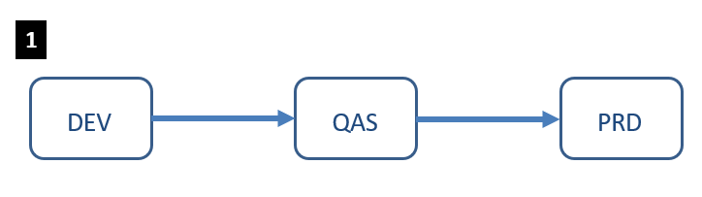
Figure 4-1 : Software Development Life Cycle
Synlait will be using following tools for transports within SAP Landscape on Azure.
- SAP HANA Transport for ABAP (HTA) for SAP HANA Deployment Infrastructure (HDI) to transport both HDI & ABAP Objects together using CTS for AS ABAP
- Change and transport System (CTS) for ABAP Transports not coupled with HANA Objects.

SAP S/4HANA Sandbox
During the Discover and Explore Phase, temporary S/4HANA Sandbox system will be built. It will be hosted on Zag AWS Environment to speed up delivery of Sandbox landscape. Sandbox system will be terminated by Mid Realisation Phase once project team will get QAS System.

Platform

Operating Systems
Azure Virtual Machines supports both Microsoft Windows and major Linux distributions i.e. Red hat, SLES, CentOS, Debian, Ubuntu. Zag and Synlait agreed, SUSE Linux Enterprise Server (SLES) will be the preferred platform for S/4HANA Landscape.
Layer | Type | Operating System
Application | LINUX_X86_64 | SUSE Linux Enterprise Server 15
Database | LINUX_X86_64 | SUSE Linux Enterprise Server 15
Application | WINDOWS__X86_64 | Microsoft Windows Server 2012 R2 or higher
Table 5.1

SUSE Linux Enterprise Server (SLES)
SUSE Linux Enterprise Server is the Synlait preferred Linux platform for SAP HANA, SAP Sybase, SAP NetWeaver and SAP S/4HANA solutions enabling optimised performance and reduced downtime as well as faster SAP landscape deployments.
All SUSE operating systems will get SAP Prerequisites configured as per SAP recommendations.
For any HA Scenario SUSE Linux Enterprise for SAP Will be considered. This version is optimised at the kernel level for SAP and contains the required cluster technology to support any future High Availability requirements.
Zag will run Automation code to configure SAP prerequisites on SLES VM’s for S/4HANA Landscape. This is cost effective solution as Zag understands that Synlait is not licensed for SLES for SAP Applications at present. Deploying SUSE will also be the target platform for any future SAP installations.
Zag will provide Synlait with a bring your own licenses (BYOL) model for SUSE, which is more economical than consuming a license as part of the Instance runtime cost. This cost can be provided to Synlait as part of the run cost. The costing and commercials of this this are dealt with via the commercial stream of Zag.
For information related to SLES & SAP Support on Azure please refer to following SAP Notes.
- SAP on Microsoft Azure: Support prerequisites (SN 2015553)
- Support Contract for SUSE Linux Enterprise Server/SAP & SUSE Priority Support for SAP applications (SN 1056161)

Microsoft Windows
Several applications in-scope require Microsoft Windows Server to operate, an example of this is Windows Remote Desktop.
The licensing and required vendor support for Microsoft Windows Server (or Windows Bastion) will be provided by Synlait. If more than 2 users are required to use Remote desktop server than windows terminal services will be provided by Synlait or additional windows VM’s can be deployed.

Compute Instances
The following principles are used to decide on the Azure Compute instance type selection for each workload and application on each landscape:
- Compute instance types will be chosen for each application, on each landscape, based on the compute, network and I/O requirements of that application. Any vendor constraints will also be considered.
- In line with cloud best practices individual database instances will be used for major databases. Multiple databases will not be ‘stacked’ into shared instances.
- Application servers will reside on their own individual (or more in case of HA requirements) instances. Applications will not be stacked together on shared instances.
- The best approximation for rightsizing will be made.
- Instance types and sizes will be revised regularly, and changed where appropriate, with a view to reducing cost and maintaining service quality.
- In all cases, the lowest cost and most modern model will be chosen, considering the requirements.
- Azure Accelerated Networking will be enabled for SAP workload, to further reduce network latency between Azure VMs.

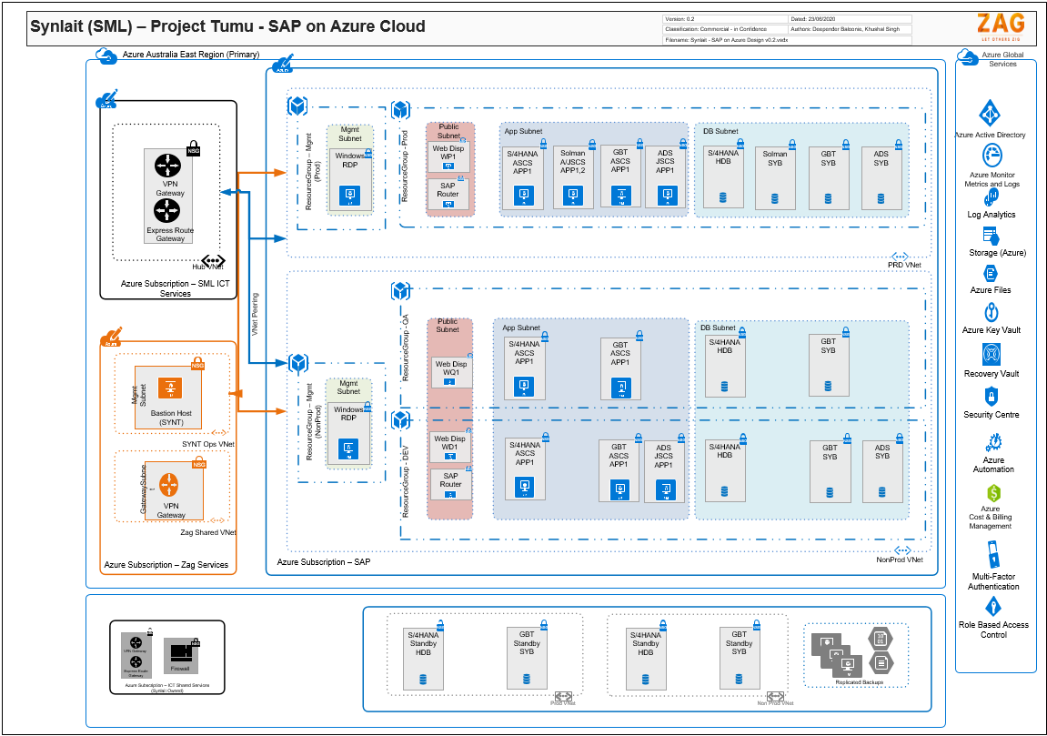
Figure 5-2: SAP Landscape in Azure (VM)

Databases
The recommended database platform matrix is as follows.
Table 5.2
Layer | Type | Operating System
SAP HANA Database | LINUX_X86_64 | SUSE Linux Enterprise Server 15
SAP SYBASE DB | LINUX_X86_64 | SUSE Linux Enterprise Server 15

SAP HANA
SAP HANA is the database for S/4HANA based SAP System. The Application Matrix below Error! Reference source not found. details the intended deployment. SAP HANA will be deployed as per SAP’s best practice for version, parameters, and database layout.

SAP Sybase
SAP Sybase DB will be used for other NetWeaver Based applications in the landscape. It is cost effective solution for Synlait. The Application Matrix below Error! Reference source not found. details the intended deployment. SAP Sybase DB will be deployed as per SAP’s best practice for version, parameters and database layout.

Application Matrix
The following table details the intended SAP platform matrix under Project Tumu Scope by application.
# | Application | Application Type | Application Codes | Database
1 | SAP S/4HANA | ABAP | SLES15 | HDB2.0
2 | SAP GBT | ABAP | SLES15 | ASE16
3 | SAP Shared JAVA | ABAP | SLES15 | ASE16
4 | SAP Solution Manager | ABAP, JAVA | SLES15 | ASE16
5 | SAP Web Dispatcher | Other | SLES15
6 | SAP Router | Other | SLES15

Table 5.3

Following table details Applications related to Software as a service.
# | Application | Application Type | Application Codes | Database
1 | SAP Data Services SAAS | Other | SAPSAAS | SAP
2 | SAP Ariba SNAP SAAS | Other | SAPSAAS | SAP
3 | M3 Infor | Other | - | Non-SAP
4 | Microservices | Other | MCS | Microsoft
Table 5.4

The following table provides a key to the above application codes for Application and Database used above.
# | Application Codes | Description
1 | SLES4SAP15 | SUSE Linux Enterprise Server for SAP Applications 15
2 | SLES15 | SUSE Linux Enterprise Server 15
3 | ASE16 | SAP Adaptive Server Enterprise DB 16.0
4 | HDB2.0 | SAP HANA Database 2.0
5 | SAPSAAS | SAP Software as a Service
6 | MCS | Azure Microservices
Table 5.5

Patch Management
The approach to update management in Azure is to utilise Azure automation to manage operating system updates for Windows and Linux systems. The following diagram describes how this will work in Azure.
Figure 5-3: Update management using Azure Automation
SAP Application & Database Update Management (for example SAP Application/DB upgrades, patching etc.) will be done manually as per Zag Managed Services Maintenance Strategy.

Time and Locale Settings
All servers for the in-scope applications will have their time zone set to, New Zealand Standard Time (NZST). Date and time for these systems will be centrally set by a Network Time Protocol daemon (NTP).
Zag use ‘chrony’ as the NTP daemon and is sync with Azure time server. Timezones internal to an application will also be set to New Zealand Standard Time (NZST).
The NZST time zone includes an offset for daylight savings.

Storage
Storage in Azure is highly available, secure, durable, scalable, and redundant. Azure Storage is the Azure platform’s managed service for providing cloud storage. Azure Storage is composed of several core services and supporting features.
Following Microsoft recommendations, ASCS will be combined with PAS on one of the VMs. In future, after evaluation ASCS can be moved to a standalone VM if required.

Following storage guidelines will be implemented for storage used in SAP environment:
- Use Azure managed disks.
- Use Azure Premium Storage for performance sensitive VMs i.e. SAP HANA and ASE DB
- For Non-HA Requirement use NFS file share on ASCS VM. This is applicable for /sapmnt folder sharing requirements.
- Use Azure Premium Storage for /usr/sap/trans directory in production landscape.
- For SAP Media or other supported requirement Azure Files can be used.
- In order to achieve Virtual Machine Connectivity of at least 99.9% single instance SLA, Zag recommends using all disks as premium types for production VMs and Mixed (standard, premium) for Nonproduction VM’s.
https://azure.microsoft.com/en-us/support/legal/sla/virtual-machines/v1_8/

Linux User Accounts
As the majority of VM’s are running Linux for an operating system, Zag will manage the user accounts that support both the operations and running of the Controlled Environment.
In general;
- Only employees of Zag that are assigned to supporting Synlait’s are provisioned to the environment.
- Only employees of Zag that required access to the Operating System are provisioned to the environment.
- Zag employees are issued with a named account based on first and last name.
- Only Zag employees have the right to evaluate privileges or 'sudo' to root access.
- Zag employees will use individual SSH keys for secure authentication.
- Application accounts will only be provisioned to VM’s that require that account to operate.
- Application accounts have restricted access and no rights to evaluate privileges or 'sudo' to root access.
- All Linux Accounts within the environment will have the password delete flag enabled upon.
- All VM’s have SSH password login disabled as per our CIS standard.
- Access to the root account is via sudo only as the root account is disabled for remote logins.
All authentication attempts are logged within the environment, failed attempts are reported upon.

Connectivity
SAP S/4HANA Landscape on Azure will provide connectivity to the following trusted user communities:
- Synlait Corporate Offices, New Zealand.
- Synlait supported vendor such as Zag will access SAP Landscape via Internet
- Synlait supported vendor such as SAP HEC Data Services will access SAP Landscape.
- Synlait Azure Platform hosting Middleware Application MCS
- Synlait supported vendor SAP Ariba SNAP will access SAP Landscape
- Fiori Mobile app will access SAP Landscape
Each user community is seen as trusted and will be able to access the load balancers and associated application layer while trusting the HTTPS certificates involved.
The SAP application on Azure platform is not being made externally available to the internet. External requirements such as integration will be provided by agreed method. This integration method ensures that connectivity between parties is done via a proxy with access and security controls that meets Synlait’s requirements.
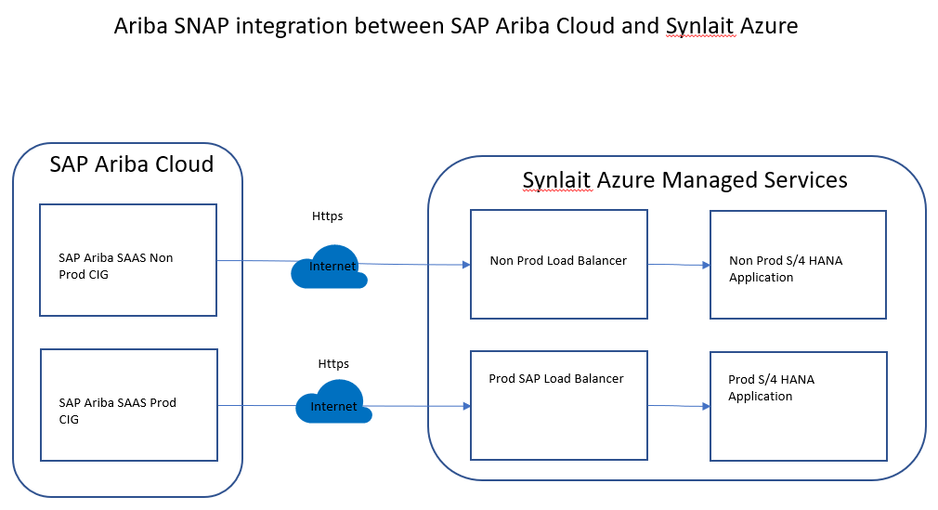
Figure 5-4: SAP Ariba Network connectivity with Azure SAP VM’’s
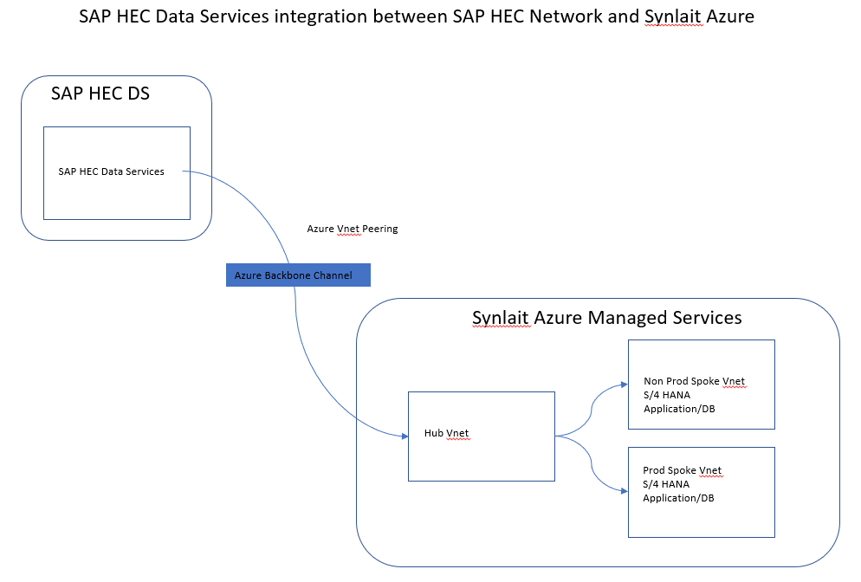
Figure 5-5: SAP HEC DS Network connectivity with Azure SAP VM’’s

SAP

Environment

Standalone Components
The patching and maintenance of any standalone component is governed by Software Release Cycle.

SAP Web Dispatcher
The SAP Web Dispatcher acts as a reverse proxy that retrieves resources on behalf of a client from one or more servers. These resources are then returned to the client as though they originated from the proxy server itself. As a ‘software web switch’, the SAP Web Dispatcher can reject or accept connections. When it accepts a connection, it balances the load to ensure an even distribution across the applications servers within the SAP instance.
The recommendation has been made to utilise the SAP Web Dispatcher for the following reasons.
- Resides within the SAP ecosystem on Azure Platform
- SAP aware, certified and supported
- Confirms with Zag standard reference architecture
Due to the HA limitations of the SAP Web Dispatcher, Zag recommends utilising a Cloud providers load balancers solution, such as Azure Standard load balancers or application gateway as required and evaluated. This provides the main entry point for all system to system communication and end user connectivity for traffic flowing through Public internet.
SAP Web Dispatchers on Azure Cloud are bound to DNS “friendly” names to allow better familiarisation to the backend server they cater for.
Refer to section 5.8 for Connectivity guidelines.

SAP Router
SAP Router is an SAP program that acts as an intermediate station (proxy) in a network connection between SAP Systems, or between SAP Systems and external networks. SAP Router controls the access to your network (application level gateway), and, as such, is a useful enhancement to an existing firewall system (port filter).
The SAP Router will be utilised to secure the connection between SAP Support Systems and Synlait. A SAP Router can encrypt and authenticate against another SAP Router, in this way, we can establish a secure tunnel for communications between components that may not be able to use Secure Network Communications (SNC).

SAP Diagnostics Agent
The SAP Diagnostics Agent (DAA) is a central component of the SAP Landscape and provides performance and system data of the connected systems to SAP Solution Manager. As part of Synlait Project Tumu existing new SAP Solution Manager system will be installed, for each system a new Diagnostics Agent will be installed (Azure SAP VM) and connected (Solution Manager). The SAP Diagnostics Agent is installed per host for all SAP allocated machines, this includes any database servers.

SAP Host Agent
SAP Host Agent is an agent that can accomplish several life-cycle management tasks, such as operating system monitoring, database monitoring, system instance control and provisioning. The SAP Host Agent is installed per host for all SAP allocated machines, this includes any database servers.

Hostnames
In order to support future migration of existing on-premise SAP servers Zag defines hostname standard for SAP servers.
The general rule for hostnames is according with RFCs 952, 1101, 1123, 1178 (http://ietf.org/rfc). In addition, some SAP specific restrictions apply that are detailed in SAP note, Hostnames of SAP servers (SN 611361).
As a rule of thumb; alphanumerical string of alpha characters [A-Z], [a-z], [0-9] and the hyphen (or minus) character “-“with a maximum of 12 characters in length. Although the newer RFCs permit hostnames beginning with digits, SAP recommend hostnames to begin with an alpha character. The period character “." is only allowed to delimit components of domain names like saperp.company.com.nz or saperp.dev.mycompany.com.nz
Refer to section 3.9 for details on DNS naming.
Zag’s Reference Architecture (ZRA) ensures compliance with such standards and in general, SAP applications are installed against the physical hostname of a Cloud instance. SAP Central Services (A/SCS) and Databases Services are installed or referenced against a virtual hostname, load balancer to facilitate failover between a Cloud providers datacentres concept.
Physical hostnames are assigned as per the following ZRA standard, the standard for virtual addresses are provided as well.
SAP Layer | Hostname | Technology
Application Servers 1 | <customer code><sapsid><01-39> | Any
Application Servers 2 | <customer code><sapsid><41-79> | Any
Central Service | <customer code><sapsid><81-89> | Cluster
Database | <customer code><sapsid><91-99> | Any
Table 6.1
Virtual hostnames are utilised to decouple the SAP systems from the physical network identities and servers and provide flexibility when relocating or failing-over SAP systems or components between physical servers. In general, no SAP application or component is to be installed against a virtual hostnames or IP address (i.e no SAPINST_USE_HOSTNAME)
All components will be installed against the physical host name.

DNS alias's or CNAMES will be used to provide friendly names to assist Administrators in identifying the service. e.g.: A load balanced RFC destinations.

Application Layer | Alias | Service Level
Central Services | <sapsid>scs | Any
Database Services | <sapsid>db | Any
Table 6.2

The customer code is a four-character identifier that is assigned by Zag. For ex. customer code ‘SYNT’. The <sapsid> variable is the three-character SAP System Identifier, in the case of a migration this can be historical, for a new installation the ZRA defines this.
The hostname is suffixed with an incremental unique numerical value, all hostnames are defined in lowercase and are static against an allocated IP Address. Hostnames are defined within DNS only (when available) of the Cloud provider and any remote consuming party.
The following table defines the end user friendly address per application type, refer to section 4.4 for ‘tier’ information.
# | Application | Type | Non-Production | Production
1 | SAP S/4HANA | ABAP | saps4-<tier>. | saps4.
2 | SAP GBT | ABAP | sapgbt-<tier>. | sapgbt.
3 | SAP ADS | JAVA | sapads-<tier>. | sapads.
4 | SAP Solman | ABAP, JAVA | Not Applicable | sapsm.
Table 6.3

SAP System ID
The SAP System ID (SAPSID) is a unique identification code for every SAP installation. An installation consists of a database server, Central Services and Application Server(s). The SAPSID consists of a three-character code such as ‘SD1’. The following also is applicable when defining the Database System ID <DBSID>.
Customers SAP System ID’s must be:
- Unique throughout the organisation or customer
- Consists of exactly three alphanumeric characters
- Contains only uppercase letters
- Has a letter for the first character
- Is not reserved by SAP
Following SAP SID Naming conventions will be implemented as part of the project and support future installations.
The SAP system identifier (SAPSID) naming conventions are based on the following structure:
“<PRODUCT_KEY><ENVIRONMENT_KEY><NUMBER>”
Where:
- PRODUCT_KEY is one of the following values:

Application | Also Known As | Alias | Key
SAP-S4/HANA |  | S4 | S
SAP-GBT |  | GB | G
SAP-Solution Manager |  | SM | M
SAP-Shared-Java |  | SJ | J
SAP-Router |  | RT | R
SAP-Web-Dispatcher |  | WD | W
SAP-HANA-Database |  | HDB | H
Sybase-ASE-Database |  | SYB | N/A
Table 6.4
- ENVIRONMENT_KEY is one of the following values:
ENVIRONMENT_KEY | Description
D | Development
Q | Quality Assurance
P | Production
Table 6.5
- NUMBER is a numerical value from 1 – 9, starting at “1”
SAP System ID | Description
SD1 | SAP S/4HANA Development
WQ1 | SAP Web Dispatcher Quality Assurance
HP1 | SAP S/4HANA Production
Table 6.6
Following table shows SAP applications under project Tumu scope
# | Application | PRODUCT_KEY | DEV | QAS | PRD
1 | SAP S/4HANA | S | SD1 | SQ1 | SP1
2 | SAP GBT | G | ND1 | NQ1 | NP1
3 | SAP Shared JAVA | J | JD1 | - | JP1
4 | SAP Solution Manager | M | - | - | MP1, MP2
5 | SAP HANA Database | H | HD1 | HQ1 | HP1
6 | SAP Sybase Database | - | - | - | -
7 | SAP Web Dispatcher | W | WD1 | WQ1 | WP1
8 | SAP Router | R | RD1 | - | RP1
Table 6.7
Following Application do not follow similar naming convention as they are seen as Software as a service. They belong to Project Tumu
# | Application | PRODUCT_KEY | DEV | QAS | PRD
1 | SAP Data Services SAAS | - | - | - | DS Production
2 | SAP Ariba SNAP SAAS | - | - | Ariba Snap Quality | Ariba Snap Production
Table 6.8
Following figure shows applications under project Tumu scope, Software as a service and Middleware applications. In addition to table 6.7 above following is the full form of acronym used.
DS1 – SAP SAAS Data Services Production
AS2 – SAP Ariba SNAP Cloud Quality
AS3 – SAP Ariba SNAP Cloud Production
MCDEV – Microservices Development
MCTST – Microservices Quality
MCPRD – Microservices Production
M3DEV – M3 Infor Development
M3TST – M3 Infor Quality
M3PRD – M3 Infor Production
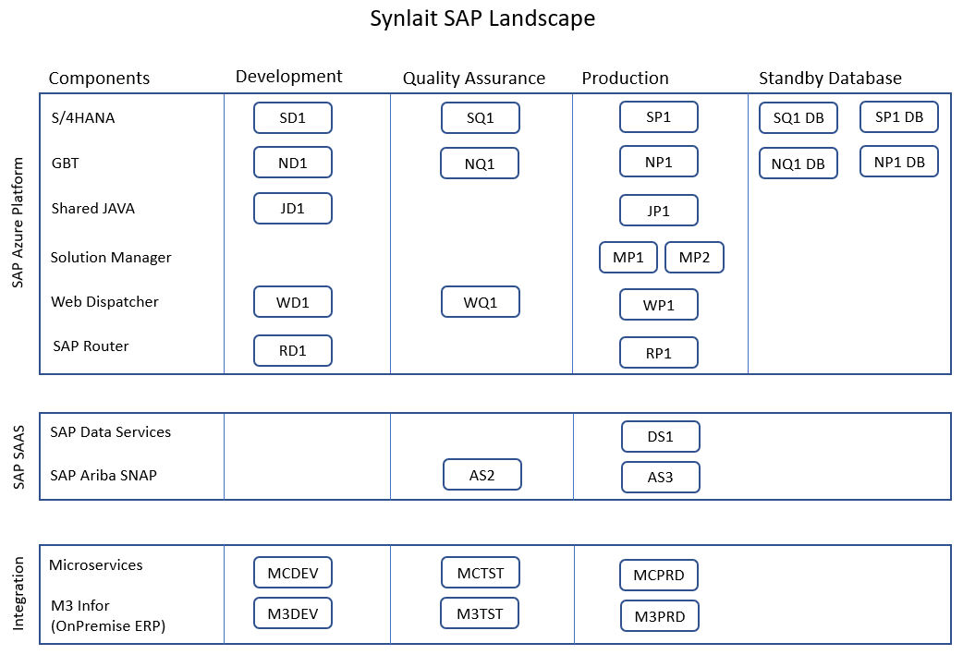
Figure 6-1 : Synlait SAP Landscape

SAP Ports
The following table lists the SAP process and provides a description of the function that the port is listening for. Note that this table primarily shows the connections from client i.e user to SAP server.
SAP Application | SAP Component | Port | Description
SAP ABAP | Dispatcher | 3201 | SAP Dispatcher, used by SAP GUI for Windows/ JAVA
 | Gateway | 3301 | SAP Gateway, used for CPIC and RFC communication
 | Message Server | 3680 | SAP Message Server, used by Load Balancing
 | HTTP | 80 | HTTP connection, redirect to HTTPS
 | HTTPS | 443 | HTTPS connections
SAP HANA | Indexserver | 31013,  31041 | Indexserver SQL/MDX Port System DB, Indexserver SQL/MDX Port Tenant DB Used by SAP APP and HANA Studio Connections
 | HTTPS | 31033 | XSA hostname routing
Table 6.9

SAP System Number
The SAP System Number is a technical identifier for internal and external application processes. It consists of a two-digit number ranging from ‘00’ to ‘99’. The system number must be unique for a given host per component. In addition, supplementary SAP components such as a Diagnostics Agent, Host Agent and Web Dispatcher all require an SAP System Number to be assigned.
The SAP System Number defines a variable that is used to determine several technical identifiers of the SAP Instance. One of which is the port that an SAP application accepts connections on, being either RFC-DIA(S) and/or HTTP(S). This rigid standard allows associated ports to be easily identified and secured within a Cloud providers security or access control framework. Such security or control can be set against an SAP component per application type.
The following table shows the allocation of system numbers per SAP component; note that the allocation of a system number is not subject to the tier that an application resides in i.e. the table below is global across the entire landscape. System numbers in brackets allow an SAP component to be stacked if required.
SAP Component | SAP System Number
SAP ABAP Application Server | 01
SAP JAVA Application Server | 02
SAP ABAP Central Services | 80
SAP JAVA Central Services | 83
SAP Web Dispatcher | 86 (87) (88) (89)
SAP Diagnostics Agent | 98
SAP Host Agent | 99
SAP Router | 99
SAP HANA Database | 10 (11) (12)
Table 6.10

Correction and Transport System
Refer to Section ‎0 for high level overview of Transport management process.
The underlying filesystem ‘/usr/sap/trans’ that supports CTS+ (Enhanced change and transport system), is deployed by application and by tier. There is no central filesystem for all applications, and filesystems do not span tiers, i.e. mounted from Development to Quality Assurance to Production. Transports are migrated from system to system, domain to domain via the standard process available within SAP application layer.

SAP Client Strategy
Following client strategy will be reviewed based on refresh process for SAP ABAP systems on HANA.
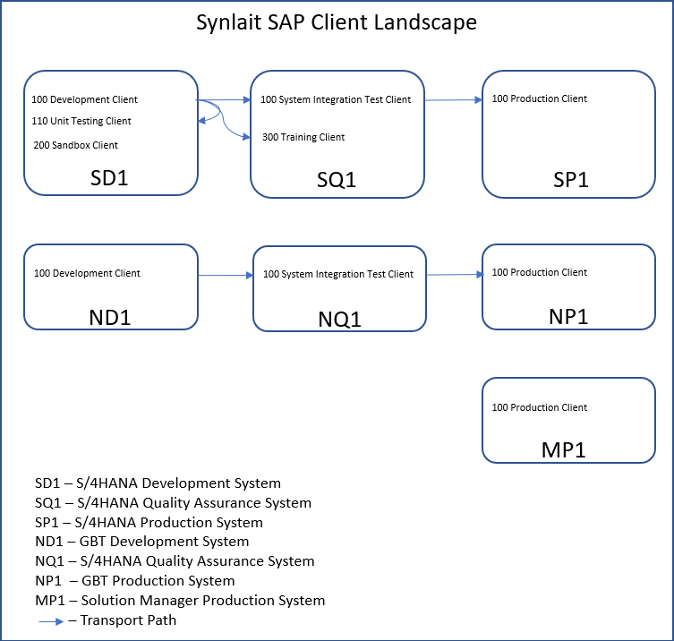
Figure 6-2 : Synlait SAP Client Landscape

System Landscape Directory
SAP Solution Manager (Solman) covers the complete application lifecycle of SAP solutions running on premise, hybrid or in the cloud. SAP Solman Landscape Directory (SLD) will be utilised for S/4HANA systems in Azure. Synlait Solman SLD contains detailed information about all components in the SAP solution landscape.
The SLD object server naming convention is “Synlait<SAPSID>”.

Software Vendor Support
As introduced in the standalone component section of this document the SAP Router is an SAP program that acts as an intermediate station in a network connection between SAP systems and external networks. SAP router controls the access to your network and is a useful enhancement to an existing security system, allowing SAP support access to the SAP landscape when required.
The SAP Router is also used for systems to download SAP Notes and metadata from SAP. The connection method to be used will be Secure Network Communications (SNC). On Premise SAP Router will be used for connection between SAP Active Global Support and SAP S/4HANA systems over Azure platform.
For more details on SAP Router deployment refer to section 6.1.3.

S/4HANA Target State
This Section gives details about target State of SAP S/4HANA Landscape on Azure. Below section focuses on S/4HANA Sizing, infrastructure components.

SAP Sizing
Since this is greenfield implementation, sizing approach is taken to start with lower sized machine and increase the size as per usage. Non-Production (Development and Quality) SAP servers are sized lower than production environment to save the cost. Non-Production Environment will be scaled as per the usage.
SAP HANA will be deployed on Azure IAAS platform
https://www.sap.com/dmc/exp/2014-09-02-hana-hardware/enEN/iaas.html#categories=Microsoft%20Azure%23SLES*%2015
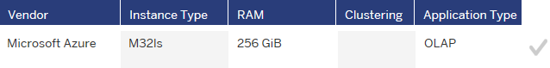
Figure 7-1 : SAP HANA VM on Azure IAAS
Instance M32ls will be provisioned for S/4HANA DB Production instance. Instance D4sv3 will be provisioned for S/4HANA PAS Production Instance. As per storage guidelines managed disks will be used. Premium disks are recommended for DB & I/O intensive Workloads.

Infrastructure Requirements
For each tier the 'Synlait - SAP Technical Infrastructure Requirements' spread sheet provides a breakdown of hardware requirements for each instance or host.
The Technical Infrastructure Requirements spreadsheets provides the following detail:
- The SAP application installed on a host
- The SAP System ID
- Hostname and primary IP address
- Installed database components
- Installed operating system
- Cloud provider details and particularities
- SAPS rating by Azure instance type
- CPU and RAM allocations by instance type
- File-system layout, associated sizes and storage types
- Assigned shared filesystems
- User & groups assigned at the operating system level
- Assigned tagging profile
- General notes and backup allocations

# | Document Title | Version
1 | Synlait - SAP Technical Infrastructure Requirements | 0.1
Table 7.2

Hour of Operations
The following table shows the intended hours of operating for SAP systems per tier as per workshop, batch schedules within systems will need to be defined accordingly.
# | Tier | Code | Hours of Operating
1 | Development | DEV | 08:00 to 20:00 NZST, Monday to Friday
2 | Quality Assurance | QAS | 08:00 to 20:00 NZST, Monday to Friday
3 | Production | PRD | 24 x 7 x 365
Table 7.3
Automation will be used to start and stop the VMs as per the given schedule. This also supports the sequence in which components are started and stopped. It is worth mentioning that all the services running inside the VM must be configured to start and stopped automatically with the system.

Operations

Solution Manager
SAP Solution Manager is the central lifecycle management hub for SAP systems and SAP solutions, being either on premise or in the cloud. It accelerates innovation, manages application lifecycles, and runs solutions on the single integrated business and IT platform.
The Synlait SAP environment contains one Production SAP Solution Manager system. The SAP Solution Manager system will be used for the following functions with respect to S/4HANA landscape:
- Technical monitoring and alerting
- Earlywatch Alert reporting

High Availability/Disaster Recovery
Availability requirements are captured as per below table.
# | Requirement | Production | Non-Production
NFR-1 | Hours of Operation | 24 x 7 | Monday to Friday on a 08:00 am to 08:00 pm NZST
NFR-2 | Availability | No High Availability.  Standby DB will be setup for Production DB DR Scenario only  During this uptime (logon to application and transact), the business requirement is for 99.5% availability, represented by approximately downtime of:  7.2 minutes per day  3.6 hours per month  1.83 days per year  Agreed maintenance and maintenance windows are excluded from this measure.  Microsoft planned or unplanned downtime is excluded from this measure.  This availability requirement is based on Hours of Operation metric. | No High Availability  Standby DB will be setup for QAS DB DR Scenario only  During this uptime (logon to application and transact), the business requirement is for 95% availability, represented by approximately downtime of:  1.2 hours per day  36.53 hours per month  18.26 days per year  Agreed maintenance and maintenance windows are excluded from this measure  Microsoft planned or unplanned downtime is excluded from this measure.  This availability requirement is based on Hours of Operation metric
NFR-3 | Maintenance Window - Disruptive | 1 Hr every quarter | As required, during the Hours of Support (08:00 am to 05:00 pm)
NFR-3A | Maintenance Window - Non-Disruptive | Sunday 7.30 pm to 08:00 pm | As required, during the Hours of Support (08:00 am to 05:00 pm)
NFR-4 | Recovery Time Objective (RTO) | 8 Hours | 12 Hours
NFR-5 | Recovery Point Objective (RPO) | 15 Minutes | 2 Hours
Table 9.9.1
Standard + Standby Scenario will be implemented for Synlait Quality Assurance and Production SAP systems. Standard means Single points of failure across all 3-tiers of the SAP application which will be mitigated by monitoring and support. Standby means standby Database setup in paired region for Disaster Recovery Purposes. This provides lowest cost option. Quality Assurance environment mirrors architecture of production system. All standby systems run at a reduce hardware specification. If DR across the region is required standby systems will be resized. Production SAP Application can scale with the provision of additional application servers.
Production SAP Servers will be using premium SSD for all operating system disks and data disks to get Microsoft guarantee virtual machine connectivity of at least 99.9%.
https://azure.microsoft.com/en-us/support/legal/sla/virtual-machines/v1_9/
In case of Disaster recovery or availability RTO applies on top of Microsoft Azure SLA.

Backup & Recovery
Based on the Disaster Recovery strategy above backup Azure backup service will be decided to protect data in Azure. Azure backup services provide simple, secure, and cost-effective solutions to protect data and recover quickly in Azure Cloud. SAP HANA databases in Azure VMs are also supported by Azure Backup services. Azure backup supports 15-minute RPO for recovery of critical data.
Backup/Recoverability requirements are captured as per below table.
# | Requirement | Production | Non-Production
NFR-6 | Recoverability | All in-scope applications must be backed up in accordance with the backup policy.  The backup policy includes  VM backup (Including OS)  Full database backup  Incremental database backup  Transaction log backups  All Backups are held in a single Region → All Backups are held in a multi-region GRS | All in-scope applications must be backed up in accordance with the backup policy.  The backup policy includes  VM backup (Including OS)  Full database backup  Incremental database backup  Transaction log backups  All backups are held in a single region.
NFR-7 | Retention | All in-scope applications must be protected in accordance with the backup policy defined by the project and copies retained in a secure location.  The current policy for in-scope applications are;  Operating System backups are retained for 32 days  Full database backups are retained for 32 days  Incremental database backups are retained for 32 days  Transaction log backups are retained for 32 days  Security Logs are retained for 32 days  A monthly database backup is retained for 7 years. (Blob Storage Archive) | All iAll in-scope applications must be protected in accordance with the backup policy defined by the project and copies retained in a secure location.  The current policy for in-scope applications are;  Operating System backups are retained for 15 days  For Development systems:  Full database backups are retained for 15 days  Incremental database backups are retained for 15 days  Transaction log backups are retained for 15 days  For Quality Assurance Systems:  Full database backups are retained for 15 days  Incremental database backups are retained for 15 days  Transaction log backups are retained for 15 days  No monthly or yearly backups are taken out of cycle and retained
Table 10.9.2
The following has been defined regarding retention management within the SAP solution. The retention values specified are used to configure for data aging or delete process of technical objects i.e. iDocs, application log, workflow documents, and change documents. Hence changing these will impact the initial sizing listed within this document.
# | Requirement | Description | Retention
NFR-8 | Business Data: | Transactional and master data relating to the functionality of SAP application. | 7 years
NFR-8A | Business Data: | Component or applications can define their own archiving requirements as deemed necessary. | 7 years
NFR-9 | Transient Data: | Datasets that support the processing of Business Data i.e. system job logs, spool requests, interface payloads. Once processed they can be removed without impact. | 14 Days
Table 10.2

Backup Strategy
Following backup strategy will be adopted to protect the data/systems in the Azure cloud:
- Operating System: All Azure VM instances are backed-up by creating VM snapshot on a regular basis. Backup data is cleaned-up regularly.
- File system for the OS Layer: Non-database filesystems will be backed-up as part of the Operating System backup strategy, i.e. will be part of the Snapshot creation process.
- File system for shared critical volumes: Will be backed-up independently of the Operating System at the required frequency to Azure Blob storage location.
- Database Layer: Database and transaction log backups are made to a separate volume. The data on this volume is backed up using volume snapshots or sent directly to Azure Blob remote storage location.

All backups will be executed using the available vendor operating system and database toolsets. All instance backups are done to disk, sent to Azure Blob or a volume snapshot.
SAP Hana native backup utility will be used to create manual backups to local disk and then moved to Azure Blob Storage. This backup will be used to recover services in the event for primary region failure.
The use Azure blob storage Archive will be items that are held for an extended retention period as defined by Synlait. Backup in the separate region will be stored as Geo Redundant Storage (GRS) for the purpose of having second copy for production systems. There is no active-active configuration between Primary & secondary regions. This means in event of primary region failure; Backups can be restored for Recovery.
Following table lists types of backup and their storage strategy.
# | Backup Items | Retention | Frequency | Backup Replication | Tool
1 | PRD DB | 32 days | Daily | GRS | Blob-Storage Hot
2 | PRD DB Transaction Logs | 32 days | 5 minutes | GRS | Blob-Storage Hot
3 | QAS DB | 15 days | Daily | GRS | Blob-Storage Hot
4 | QAS DB Transaction Logs | 15 days | 30 minutes | GRS | Blob-Storage Hot
5 | DEV DB | 15 days | Daily | LRS | Blob-Storage Cool
6 | DEV DB Transaction Logs | 15 days | 30 minutes | LRS | Blob-Storage Cool
7 | PRD VM’s | 32 days | Daily | GRS | Azure Backup
8 | QAS VM’s | 15 days | Daily | GRS | Azure Backup
9 | DEV VM’s | 15 days | Daily | LRS | Azure Backup
10 | PRD DB Monthly DB Backup | 7 years | Monthly | GRS | Blob-Storage Archive
Table 10.3
Frequency above is estimated based on SAP system with lower updates. Requirements will need to be reviewed again if system generates increases huge number of transaction logs due to updates in the system.

Recovery
The backup environment will be designed to ensure all SAP environments are completely recoverable from backup data.
Recovery steps will be different based on type of scenario.
Recovery steps will be documented as part of Recovery Testing exercise.

Testing
Backup and restore testing will be conducted as part of the project.
Synlait indicated to perform Backup/Restore Testing once every 6 months after Go-Live in accordance with Synlait’s governance requirements.
Recovery process needs to be tested as part of project.

Monitoring & Logging

Infrastructure monitoring
Monitoring is essential to manage resources in Azure cloud platform effectively. Benefits of cloud adoption can only be realized from a well-defined monitoring strategy. This ensures the cost, health, performance, and reliability of infrastructure.
DataDog will be used to monitoring resources in Azure cloud. Datadog maximizes the availability and performance of applications and services by delivering a comprehensive solution for collecting, analysing, and acting on telemetry from cloud and on-premises environments. It helps understand how applications are performing and proactively identifies issues affecting them and the resources they depend on.
Zag will enable monitoring for all relevant components of Azure and SAP infrastructure i.e. VMs, Containers, Storage, Network, any other Azure services and SAP Components. Azure Extension for SAP will be deployed as part of Azure VM deployment.
SAP Solution manager will be used for SAP Applications End to End Monitoring. For Details refer to section 8.1

Cloud Governance
CloudHealth will be used to Analyse and manage cloud cost, usage, security, and governance. CloudHealth provides seamless integration with Azure Cloud. A set of global policies and RBAC roles will be created to provide a baseline level of governance enforcement.

Platform Logging

Azure Platform Logs
Platform logs provide detailed diagnostic and auditing information for Azure resources and the Azure platform they depend on. All the Activities that occur in Azure Cloud and Azure Resource Manager are logged in Azure Activity Log which is enabled by default.

System Logs
Syslog is configured on all the machines to log all the activities. The System logfiles will be rotated weekly using “logrotate” utility and retained locally for 30 days.

Network Flow Logs
Azure Network Watcher provides tools to monitor, diagnose, view metrics, and enable or disable logs for resources in an Azure virtual network. Network Watcher is designed to monitor and repair the network health of IaaS (Infrastructure-as-a-Service) products which includes Virtual Machines, Virtual Networks, Application Gateways, Load balancers, etc.
Due to performance and cost reasons this is only activated on need basis i.e. while troubleshooting any network related issue.

Application Logs
Logging is enabled and maintained by the respective applications configuration.

HTTPS Logging
All SAP applications process are set to log incoming HTTPS requests. The logging standard is predefined by a SAP parameters and used within SAP Solution Manager and diagnostics framework. The 'httpaccess' logs themselves reside on the SAP applications servers themselves, all logs generated are forwarded to the secure zone of store and retained as per it’s policy. Logs on the server itself are deleted after 7 days.

Security
The following section defines the general security standards for all applications in-scope for Synlait. Each application will be deployed, maintained and secured in accordance with their respective vendor best practices.

Securing Azure Platform
Microsoft provides security capabilities to protect enterprise Azure subscriptions, cloud security’s shared responsibility model requires Azure customers to deliver security “in” Azure. Following design principles will be implemented across a layered, defence in-depth strategy across identity, data, hosts, and networks.
- Enforce Multi-Factor Authentication for all Azure and SAP Fiori users.
- Minimize the number of admins/owners for entire subscription.
- Adopt the principle of least privilege
- Secure the storage account by using RBAC and Azure AD.
- Secure data in transit between an application and Azure by using client-side encryption, HTTPS, or SMB 3.0.
- Utilize Azure KeyVault to store confidential information such as passwords and keys.
- Secure the storage account by using RBAC and Azure AD
- Set data to be automatically encrypted when it's written to Azure Storage by using storage service encryption.
- Grant delegated access to the data objects in Azure Storage by using shared access signatures.
- Use analytics to track the authentication method that someone is using when they access storage in Azure.

SAP Access Requirements
The following access requirements exist for the Synlait Azure SAP environment:
- End users (Synlait Internal) to access the SAP systems via the Azure Express route using Secure Network Communication and SSL for HTTPS communication.
- End users (Synlait External) to access the SAP systems via SSL for HTTPS communication.
- Remote support access for SAP via the external-facing SAP Router, encrypted using SNC
- Remote support access for Zag via VPN connectivity, encrypted communication. This include RDP, SSH, SAPGUI access.
- Inbound connections from internet will be allowed through Hub Network into SAP Landscape.
- SAP Fiori Single Sign On will be implemented through Azure AD Integration.
- Since SAPGUI users do not include Synlait End Users, Single Sign On is not mandatory for SAPGUI.
- SAP HEC Data Services will be allowed connectivity to SAP Spoke Network via Hub Network.
- SAP Ariba SNAP SAAS will be connecting to SAP Environment via SAP Connector.

Single Sign-On
For HTTPS based SSO, SAML based Azure AD will be used. This will include all SAP Fiori users. For SAPGUI users SAP Username/Password will be used for logon and will be controlled by SAP Security. NWBC users will be using Fiori tiles to access SAP Systems.

Password Repository
All infrastructure, operating system and SAP access information is securely stored in an encrypted KeePass database. Access to this information is only available to the Zag and Synlait SAP Basis team. The password repository includes details of all standards users in all clients, as well as interface/connectivity users, administration accounts, operating system and database user accounts.

SAP Standard Users
The following rules apply to the standard SAP users:
- The standard passwords are changed in all clients
- User SAP* is locked in all clients
- The default addresses are corrected in all clients
- The user/password details are recorded in the password repository

Digital Certificates (System)
All web-based applications are to be configured to support and enforce HTTPS connections. HTTP services are only activated to facilitate the redirection of any unsecure requests to that of its associated secure counterpart.
For all HTTPS services that end-users can interact with, either directly or indirectly, these will be signed by an External Certificate Authority (CA). The issuing, management, and renewal of these certificates will be managed by Zag. Synlait may require approving the certificate issuance based on the type of certificate being procured.
All certificates issued are done within a secure fashion and stored within an application password protected keystore. In SAP-speak this is referenced as a Personal Security Environment (PSE), keystores themselves are also protected by the hosts access controls and file permissions, PSE environments are not protected by Lightweight Portable Security (LPS).

Secure Network Communications
SNC protects the data communication paths between the various client and server components of the SAP system that use the SAP protocols RFC or DIAG. There are well-known cryptographic algorithms that have been implemented by the various security products, and with SNC, you can apply these algorithms to your data for increased protection.

Data Encryption
Synlait indicated there is no encryption requirement from business. The following table defines the data encryption overview for data at rest.
Type | Provider | Encrypted | Usage
Local Storage | Azure Managed Disks | No | OS, DB and Applications
Shared Storage | Azure Managed Disks | Yes | Interface Files and Application Shares
Remote Storage | Azure Storage Accounts Blob, Archive, Files | Yes | Software Repository and Backups
HANA Database TDE | SAP | No | Transparent Data Encryption
Secure Storage in File System | SAP | Yes | The encrypted password for the SAP database user is then no longer stored in the database, but in the file system.
Sybase ASE | SAP | No | Transparent Data Encryption
Table 11.2
The files themselves i.e. a backup is not encrypted but always reside on an encrypted storage layer.

Anti-Virus
CrowdStrike™ will be installed on the VM’s running in the Azure cloud to protects against vulnerabilities, malware, and ransomware, with the broadest range of security capabilities.

Definitions
Term | Description
AZ | Availability zones (AZs) are isolated locations within data centre regions from which public cloud services originate and operate.
Basis | The technical platform that enables SAP applications to function.
BGP | Border Gateway Protocol (BGP) is a standardized exterior gateway protocol designed to exchange routing and reachability information among autonomous systems (AS) on the Internet.
CIS | Centre for Internet Security
Cloud | Is a general term for anything that involves delivering hosted services over the Internet
DBMS | A database management system (DBMS) is a software package designed to define, manipulate, retrieve and manage data in a database.
Enhancement Package | The delivery of new functionality in a cumulative software bundle replacing the affected objects in the software
Evenflow | Used as an alternative to fixed price billing, while still spreading the cost of delivering fluctuating support levels evenly over the year. In an Even flow environment, the monthly invoice would contain one consistent charge as agreed upon, accompanied by an activity report that outlines what work has been completed, how much of the budget had been utilised, and a closing balance.
Incident | An unplanned interruption to an IT Service or a reduction in the quality of an IT Service. Failure of a configuration item that has not yet impacted service is also an incident
ITSM | Refers to all the activities involved in designing, creating, delivering, supporting and managing the lifecycle of IT services.
Level 2 | Is defined as recreating the fault and determining if it is due to a failure in the software, an issue caused by incorrect process, or master data existence/setup.
Level 3 | Is defined as identifying alternatives and workarounds when faults arise, recommending process/best practice alternatives to customisation and analysing and resolving technical issues with configuration and/or programming. They will have a deep understanding and expertise on specific product(s). They participate in break fix activities, problem management, stability analysis and minor enhancements. L3 resources perform configuration or development in the product(s). If L3 support resources cannot resolve the issue or they suspect a defect in the software or service, they assign it to Level 4 Support with any additional information gathered and manage the Level 4 escalation with SAP or Azure.
Level 4 | Is defined as solving errors which are identified as a defect with the software or service and require SAP or Azure to resolved. e.g. release or a fix or patch.
NFS | Network File System (NFS) is a distributed file system protocol used in sharing data between computer systems.
Problem | A cause of one or more incidents. The cause is not usually known at the time a problem record is created, and the problem management process is responsible for further investigation.
Reserved Instance | Reservation of resources and capacity, for either one or three years, for a particular Availability Zone or region.
Resolution | Action taken to repair the Root Cause of an Incident or Problem, or to implement a Workaround.
Service Delivery Manager | A Service Delivery Manager identifies the customers’ needs and oversees the delivery of the services within the context of the SOW. The foundation of this position is establishing processes to provide consistently high levels of customer service in a cost-effective manner.
Service Request | A request for information or advice, or for a standard change defined as a new requirement, process or development or a change to an existing process or configuration to support a business process.
SOW Variation | A alteration to scope in the form of an addition, substitution or omission from the original scope in the SOW
Support Package | A cumulative software patch bundle replacing the affected objects to fix identified bugs in the software.
Third Party | An individual or party who does not have a direct connection with the SOW but who might be affected by it.
Ticket | A ticket is the generalised term used to refer to a record of work performed (or needing to be performed).
User Acceptance Testing | Is the last phase of the software testing process. During UAT, actual software users test the software to make sure it can handle required tasks in real-world scenarios, according to specifications.
VM | In computing, a virtual machine (VM) is an emulation of a computer system.
VNET | Azure Virtual Network (VNet) is the fundamental building block for private network in Azure.
Workaround | Reducing or eliminating the Impact of an Incident or Problem for which a full Resolution is not yet available. Workarounds for Incidents that do not have associated Problem Records are documented in the Incident Record.
SAP AGS | SAP Active Global Support
SAP BW | SAP Business Warehouse
HTA | HANA Transport for ABAP
HDI | HANA Development Infrastructure
CTS | Change and Transport Management System
CTS+ | Enhanced Change and Transport Management System
CHARM | Change Request Management
ZRA | Zag Reference Architecture
XSA | SAP HANA Advanced Extended Application services
Table 12.1

Tumu Programme Approval
Name | Position | Workflow / Email | Approval Signature
Chris France | Director Strategy and Business Transformation | Chris.France@synlait.com
Jesse Middleton | IS Operations Manager | Jesse.Middleton@synlait.com
Nishaka Ranaweera | IS Development Manager | Nishaka.Ranaweera@synlait.com
Nishant Bahad | Solutions Architect | Nishant.Bahad@synlait.com

Signatures indicate that this scope document has been reviewed and approved by the appropriate people in Synlait.

